The Walsall Leather Museum needs your help!
The museum is a unique resource for all lovers and scholars of equine history, saddlery and harness making, and anything and everything to do with leatherwork and trades.
AND – they have a great deal of side saddle history and items as well!
Now the museum’s future is threatened – the Walsall Council recently signed off to have the institution and its collections moved from its historic 19th-century leather factory home to a space in the town center. Many fear this relocation is only the first step in an eventual closure of the museum – and then what will happen to its superb collections?
I am deeply grateful to the Walsall Leather Museum and its wonderful staff for allowing me to use its collections and library for my research. What I’ve learned from my many visits has greatly enriched my understanding of the past – preserving and protecting this museum, its collections, and local heritage will allow countless others to do the same.
Please add your name to the petition to save the Walsall Leather Museum: https://c.org/cLwZYX8pPg
Erica Munkwitz
-------------------
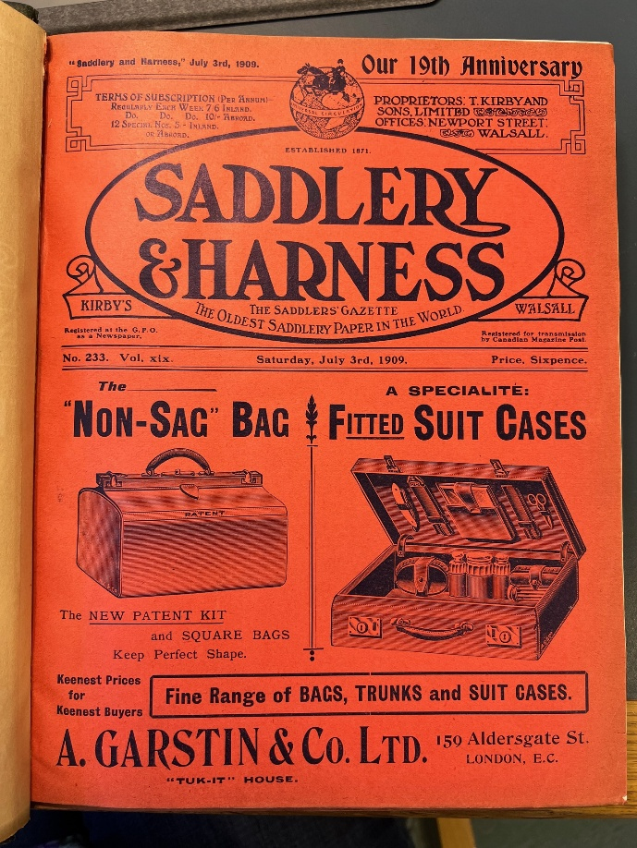
Figure 1: The museum has a full run of the rare periodical "Saddlery and Harness."

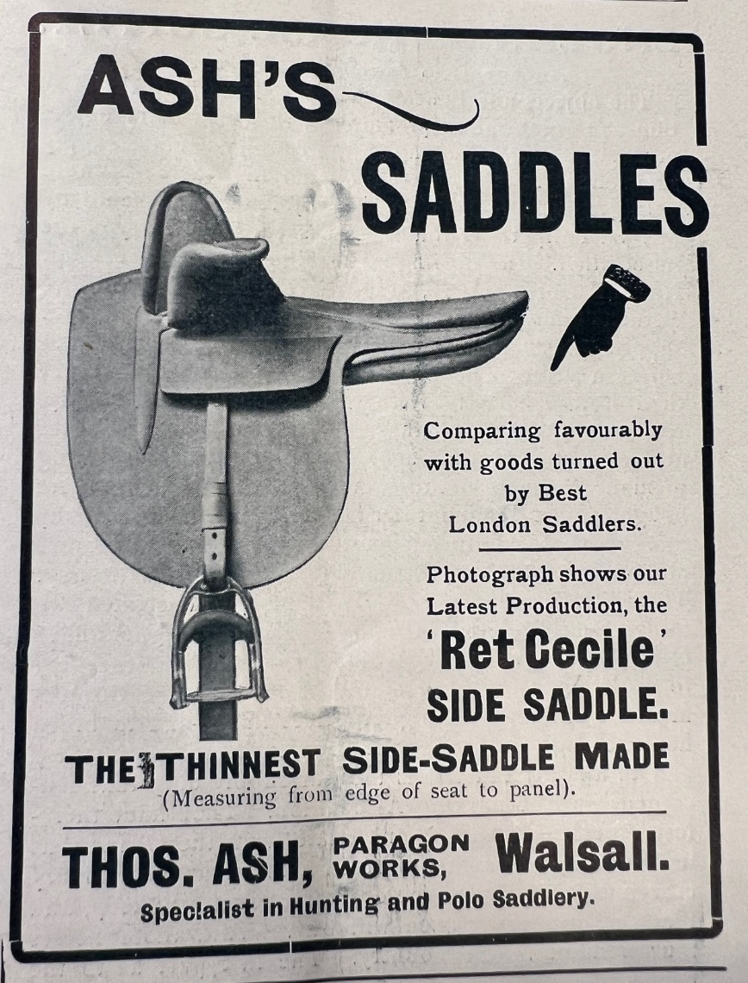
Figure 2: Side saddle advertisement from "Saddlery and Harness" from a Walsall maker.

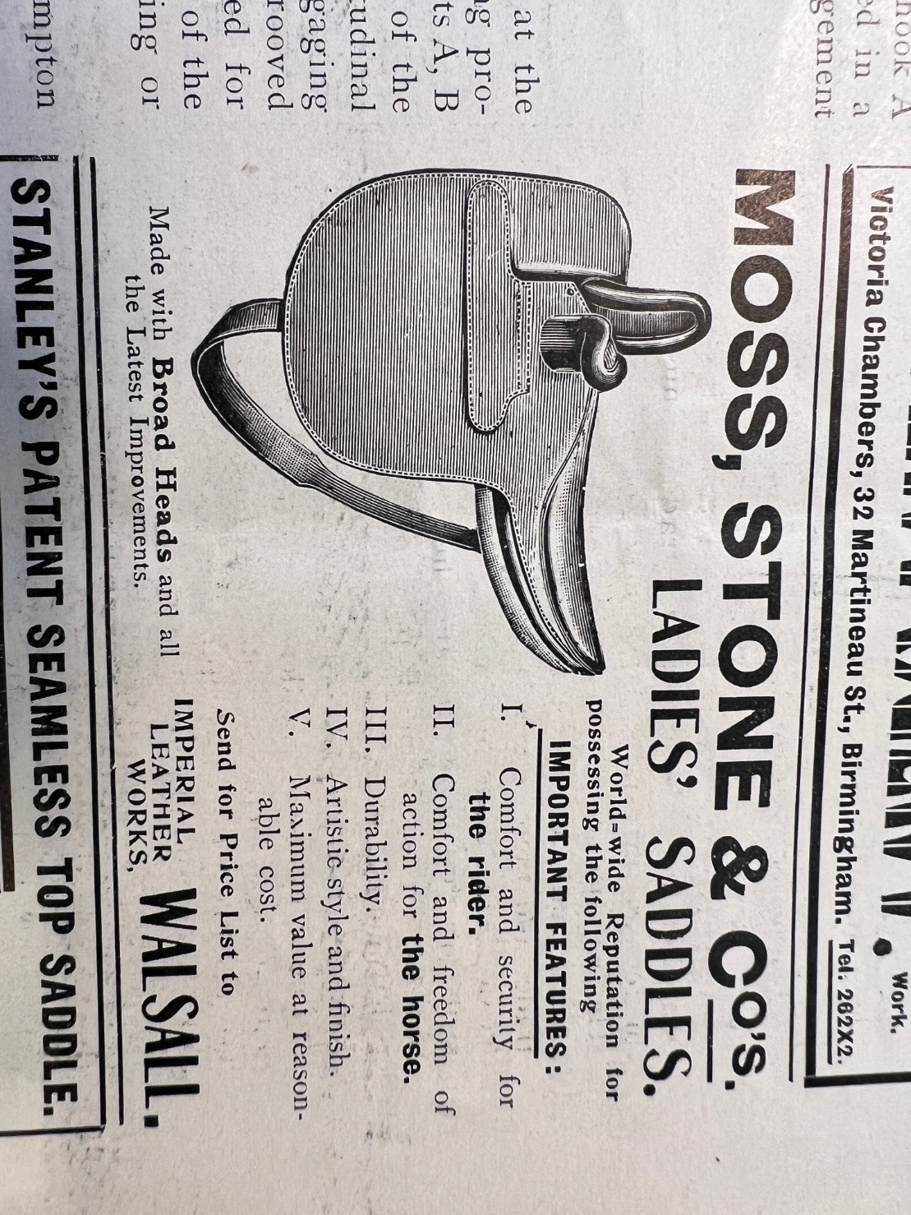
Figure 3: Side saddle advertisement from "Saddlery and Harness" from a Walsall maker.

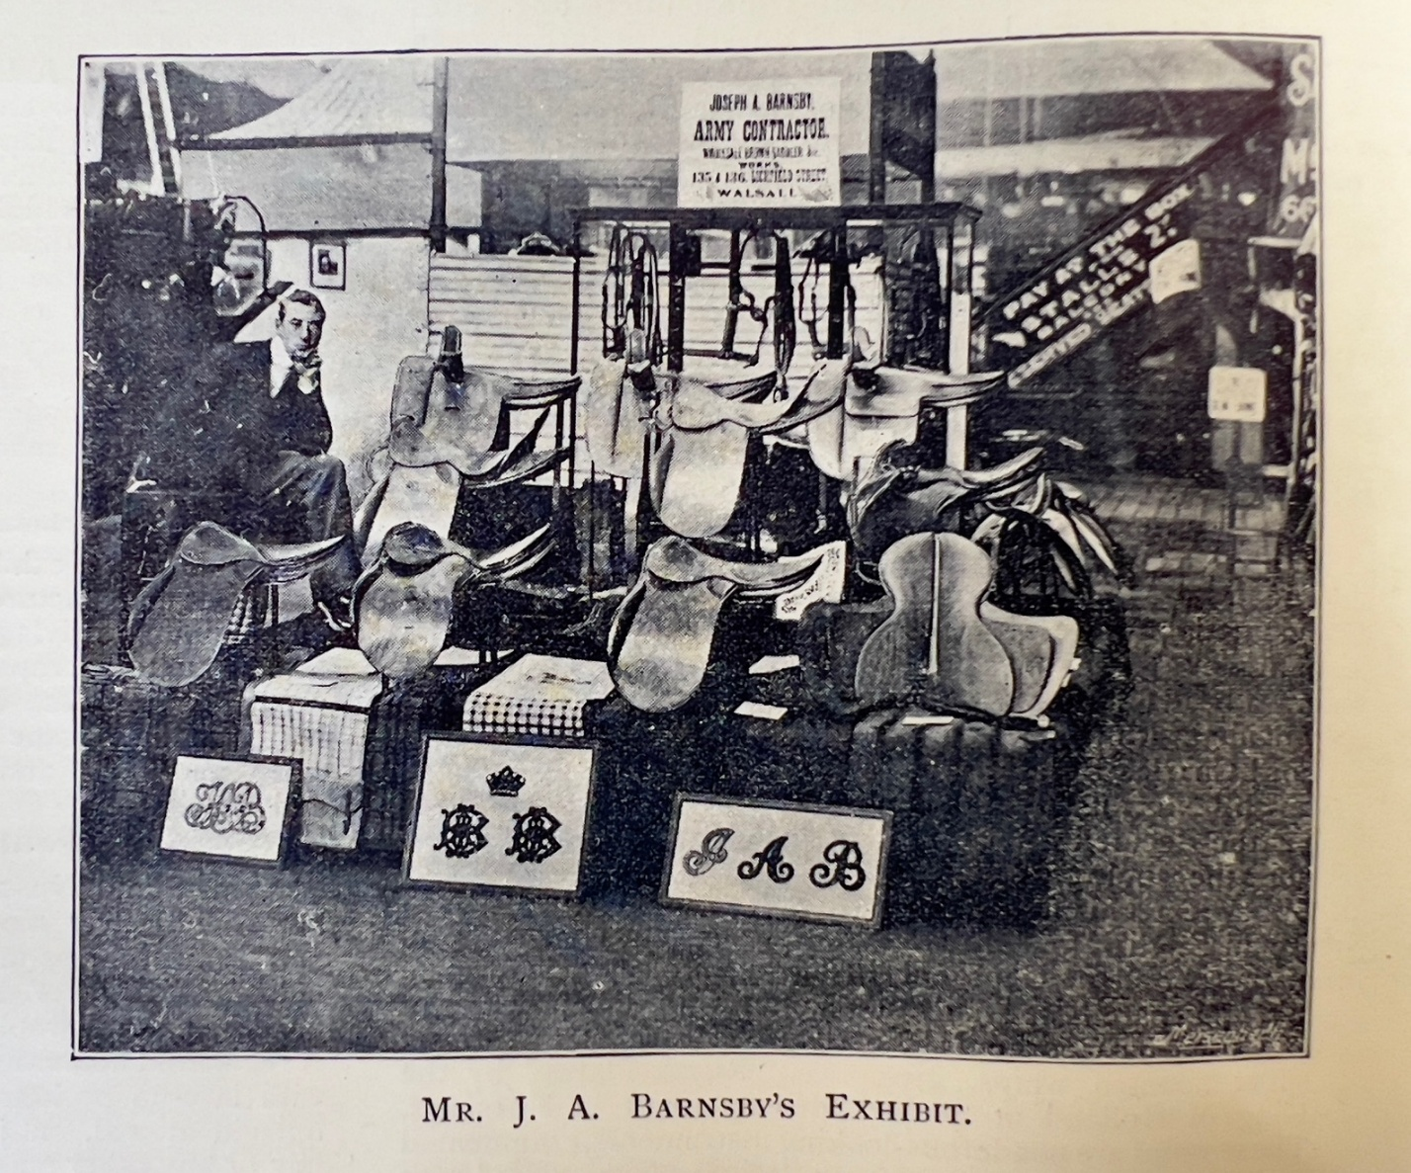
Figure 4: Barnsby saddles from Walsall, including 2 side saddles in the back row.

