LADIES SIDE SADDLE HORSE OF THE YEAR CHAMPIONSHIP 2015

Several Members of the Side Saddle Association took part in this year’s Great Scot Ladies Side Saddle Horse of the Year Championship at The Horse of The Year Show. This year the class formerly a Ladies Hunter Class was opened up to include Hacks Cobs and Riding Horses however the majority of the horses qualified were Hunters with one Hack and one Cob qualifying and only the Cob coming forward to compete with the 18 hunters which included small, lightweight ,middleweight and heavyweight.

The Members who took part were

Amelia Bevan
Gemma Chapman
Jessica Downham
Laura Gray
Lauren Hill
Katie Jerram
Sophie Lane-Keery
Emma Wilesmith

The Ladies all looked very elegant in their traditional habits and all wearing their silk hats, they certainly showed the Art and Elegance of Side Saddle Riding,
Amelia Bevan riding her own Rougemont was 4th and Gemma Chapman riding her own Atonement was 5th.

Pictured below is Amelia Bevan on Rougemeont.
Munch (Rougemont) was bought in July 2014. This season was their first season together competing. They took part in their first Ladies Hunter class in May of this year and Amelia went to the Royal International Horse Show for the first time on him. She then attempted to qualify him for the Horse of The Year Show in the Ladies Side Saddle Show Horse of The Year Final where he was very consistent and managed to qualify at Bucks County Show winning a very strong class. The family went to HOYS feeling blessed that they had even managed to qualify and had the opportunity to ride there but he rose to the occasion and gave Amelia the ride of her life and made one of her lifetime dreams come true by finishing 4th.

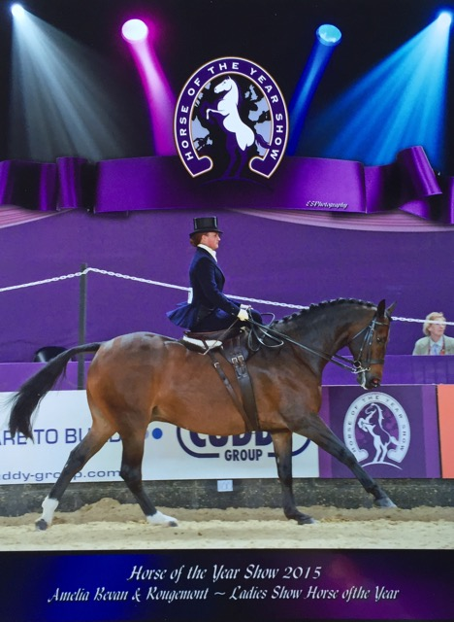

Well done to the SSA ladies and all their supporters.

